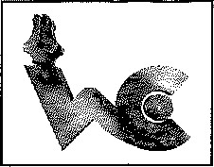 Quotation Marks
l. Direct quotations
2. Split quotations
3. End punctuation in quotations
4. Quotations within quotations
5. Quotation marks in titles
- Use direct quotations to show the exact words of a speaker or indicate dialogue.
Examples:
Jack replied, “Yes, I plan on seeing her at school tomorrow.”
“I'm so glad I did well on the test,” Mary said.
- Split quotations are used when a writer interrupts the exact words of a speaker, or a break in dialogue.
Examples:
“I'm sorry,” Grandma said, “I can't hear you.”
“Lucy,” she exclaimed, “they used the dye you gave them to make colorful T-shirts!”
- Punctuation is placed inside the quotation marks.
Examples:
“I'd prefer Chinese food,” replied Greg.
“The puppy looks like he's feeling better today.”
- Quotations within quotations. Use single quotation marks to enclose quoted material within a direct quotation.
Examples:
Tommy told her, “When I talked to Helen, she said, ‘Do not refer employees to this department.’” “When someone sneezes, you should say, ‘Bless you,’” the child told her father.
- In many citation styles, such as MLA, use quotation marks for article, essay, chapter, and short story titles, and for songs, and poems.
Examples:
I found an article titled “World War II Rhetoric and Propaganda” fascinating.
Don't you love the song “An Eye for an Eye” on The Hartford Trio's Here and Now album?

Washington State University Vancouver Writing Center

